SCHOOL

Semester One Examination, 2013

Question/Answer Booklet

MATHEMATICS 3C
SOLUTIONS

Section Two:

Calculator-assumed

Student Number: In figures

In words

Your name

Time allowed for this section
Reading time before commencing work: ten minutes
Working time for this section: one hundred minutes

Materials required/recommended for this section

To be provided by the supervisor
This Question/Answer Booklet
Formula Sheet (retained from Section One)

To be provided by the candidate
Standard items: pens, pencils, pencil sharpener, eraser, correction fluid/tape, ruler, highlighters

Special items: drawing instruments, templates, notes on two unfolded sheets of A4 paper, and up to three calculators satisfying the conditions set by the Curriculum Council for this examination.

Important note to candidates

No other items may be used in this section of the examination. It is your responsibility to ensure that you do not have any unauthorised notes or other items of a non-personal nature in the examination room. If you have any unauthorised material with you, hand it to the supervisor before reading any further.

Structure of this paper

Section | Number of questions available | Number of questions to be answered | Working time (minutes) | Marks available | Percentage of exam
Section One:  Calculator-free | 7 | 7 | 50 | 49 | 33
Section Two:  Calculator-assumed | 13 | 13 | 100 | 100 | 67
 |  |  | Total | 149 | 100

Instructions to candidates

- The rules for the conduct of Western Australian external examinations are detailed in the Year 12 Information Handbook 2013. Sitting this examination implies that you agree to abide by these rules.

- Write your answers in the spaces provided in this Question/Answer Booklet. Spare pages are included at the end of this booklet. They can be used for planning your responses and/or as additional space if required to continue an answer.
- Planning: If you use the spare pages for planning, indicate this clearly at the top of the page.
- Continuing an answer: If you need to use the space to continue an answer, indicate in the original answer space where the answer is continued, i.e. give the page number. Fill in the number of the question(s) that you are continuing to answer at the top of the page.

- Show all your working clearly. Your working should be in sufficient detail to allow your answers to be checked readily and for marks to be awarded for reasoning. Incorrect answers given without supporting reasoning cannot be allocated any marks. For any question or part question worth more than two marks, valid working or justification is required to receive full marks. If you repeat an answer to any question, ensure that you cancel the answer you do not wish to have marked.

- It is recommended that you do not use pencil, except in diagrams.

Section Two: Calculator-assumed (100 Marks)
This section has thirteen (13) questions. Answer all questions. Write your answers in the spaces provided.

Working time for this section is 100 minutes.

Question 8 (7 marks)
Two independent events A and B are such that 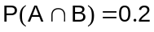 and 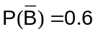.

(a) Calculate
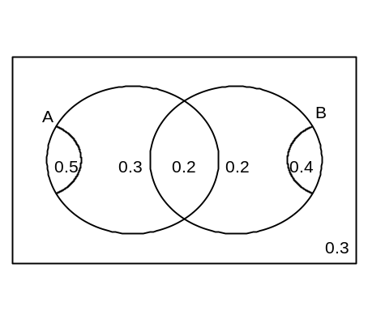
(i) 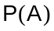 (2 marks)
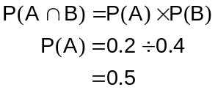

(ii) 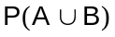 (1 mark)
0.7

(iii) 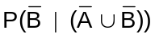 (2 marks)

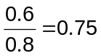

(b) A third event, C, is complementary with event A.
What is the maximum possible value of 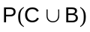? (2 marks)
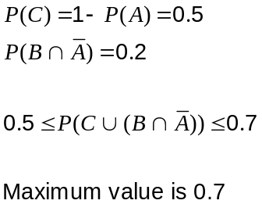

Question 9 (8 marks)
It is estimated that 6% of gift cards sold by a retail store are never redeemed.

(a) One day, 23 gift cards were sold. Let 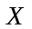 be the number of these gift cards that will not be redeemed.

(i) Define a suitable probability distribution to model . (1 mark)

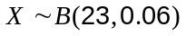

(ii) State the mean and standard deviation of this distribution. (2 marks)
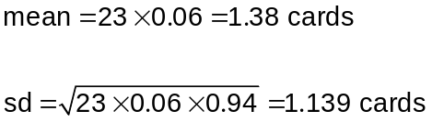

(iii) Calculate 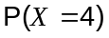. (1 mark)
0.0354

(iv) Calculate 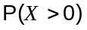. (1 mark)
0.7590

(v) What is the most likely number of gift cards that will never be redeemed? (1 mark)

1 gift card

(b) What is the minimum number of gift cards that must be sold, so that the probability that at least one of them will not be redeemed exceeds 90%? Justify your answer. (2 marks)

By trial and improvement, or otherwise, must sell at least 38.

If 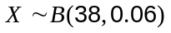 then 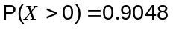

If 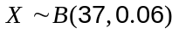 then 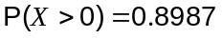

Question 10 (8 marks)
A six-sided die has faces marked with the numbers 1, 2, 3, 4, 5 and 6. The die is biased and the probability associated with each outcome is given in the table below. is the number showing on the upper face of the die when it comes to rest after being thrown and is a constant.

 | 1 | 2 | 3 | 4 | 5 | 6
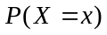 | 0.1 |  | 0.2 | 0.2 | 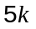 | 0.2

(a) Determine the value of 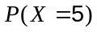. (2 marks)
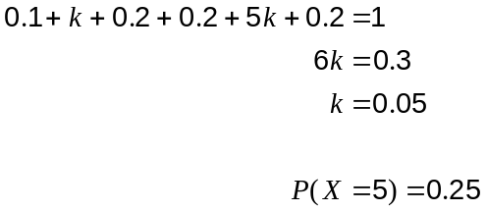

(b) Is the random variable continuous or discrete? Briefly explain your answer. (1 mark)
Discrete - the random variable can only take six specific values.

(c) The die is thrown twice. Determine the probability of an even number and an odd number being thrown, in either order. (2 marks)
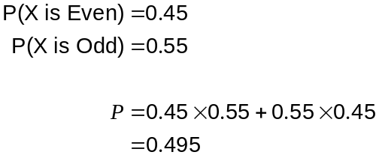

(d) The die is thrown three times. Determine the probability of a total of 16 or more when the three numbers are added together. (3 marks)

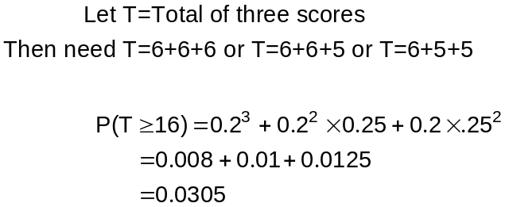

Question 11 (9 marks)
The intensity of light measured by a lux meter in a dark room, milliseconds after a lamp is turned on, is modelled by the function 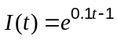 for 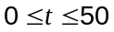.

(a) Sketch the graph of 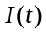 on the axes below. (3 marks)
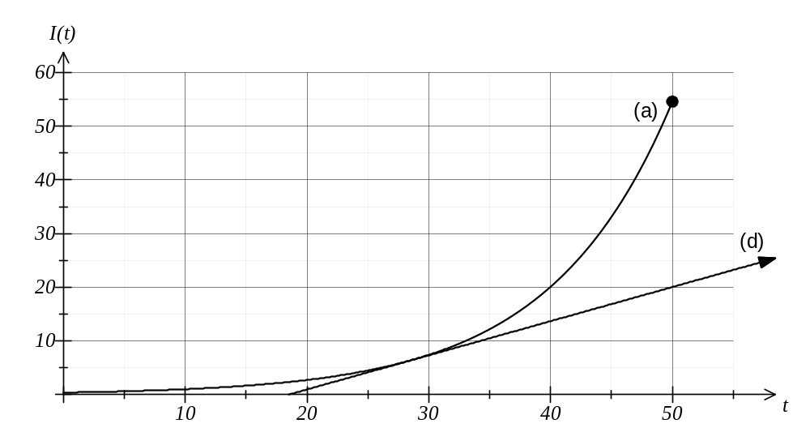

(b) Calculate the average rate of change of intensity between 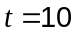 and 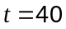.
(2 marks)
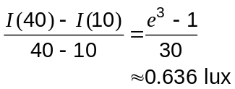

(c) Determine the time at which the instantaneous rate of change of intensity is the same as your answer to (b). (2 marks)

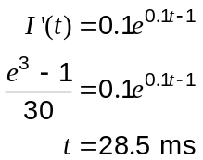

(d) On the axes above, draw a tangent to the graph of which has the same rate of change as your answer to (b). (2 marks)

Question 12 (6 marks)
An automated doughnut machine produces doughnuts with weights, 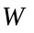, that are uniformly distributed between 47 g and 57 g, with a mean of 52 g and a standard deviation of 2.89 g.

(a) Sketch the graph of the probability density function of . (2 marks)

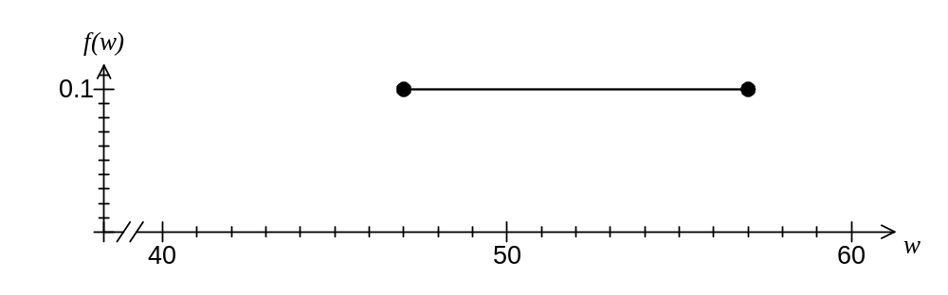

(b) What is the probability that a randomly selected doughnut produced by the machine has a weight more than one standard deviation from the mean? (2 marks)

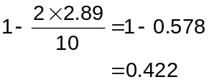

(c) What is the probability that exactly two, in a box of six randomly selected doughnuts produced by the machine, have weights more than one standard deviation from the mean? (2 marks)

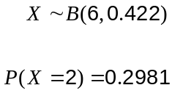

Question 13 (10 marks)
Bags of sugar packed by a manufacturer are normally distributed with mean 510 g and standard deviation of 15 g. The bags are labelled as containing 500 g of sugar.

(a) What percentage of the bags contain less than the labelled contents? (2 marks)

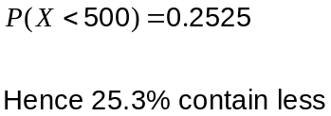

(b) What weight of sugar is exceeded by the heaviest 1% of bags? (1 mark)
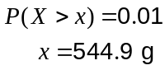

(c) Determine the interquartile range of the bag contents. (2 marks)
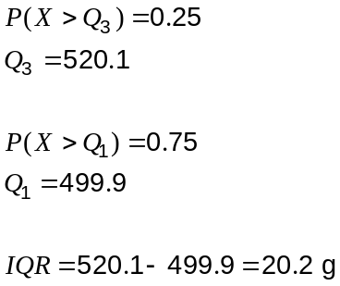

(d) Given that a bag is not underweight, what is the probability that it contains no more than 530 g of sugar? (2 marks)
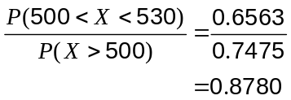

(e) The manufacturer has decided to adjust the mean contents of the bags of sugar, so that an average of one out of every 20 bags is underweight. Determine the change in the mean contents. (3 marks)
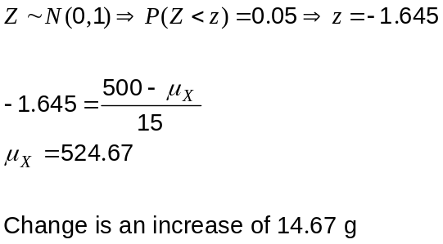

Question 14 (8 marks)
The temperature of a bronze casting after removal from an oven was observed to change according to the rule 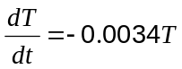 for 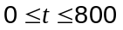.

is the temperature of the casting, in degrees Celsius, seconds after being removed from the oven.

(a) How long, to the nearest second, did it take for the initial temperature of the casting to halve? (3 marks)

Model cooling with 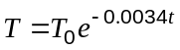.

Require 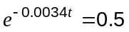

Solve to get

(b) Determine the initial temperature of the casting, given that it had cooled to 787°C after one minute. (2 marks)
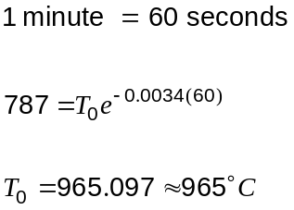

(c) Can the above rate of change model be used to calculate how long it takes the temperature of the casting to fall below 40°C? Explain your answer. (3 marks)
No.

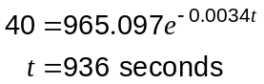

The model states , but the model predicts it will take 936 seconds which is outside this domain and so may be unreliable.

Question 15 (6 marks)
Software has been developed to classify an email message as either good or spam. The software is not perfect: only 88% of spam is classified as such, and 4% of emails that are good are classified as spam.

A large number of emails, 15% of which were spam, were checked by the software.

(a) What is the probability that the software will classify a randomly chosen email as spam?
(3 marks)

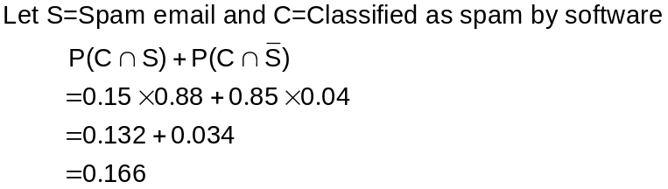

(b) Given that the software classifies an email as good, what is the probability that it is actually spam. (3 marks)

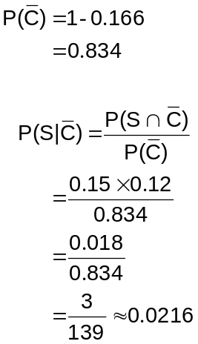

Question 16 (7 marks)
The table below contains information about the sign of , 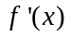 and 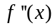 at seven points on the graph of the continuous function . Apart from those in the table, there are no other points where , or are equal to zero.

 | -3 | -1 | 0 | 2 | 3 | 4
 | - | 0 | + | + | 0 | -
 | + | 0 | + | 0 | - | -
 | - | 0 | + | - | - | -

(a) Describe the nature of the graph when 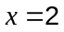 (1 mark)
Local maximum

(b) At what point is increasing at an increasing rate? (1 mark)

Where 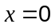

(c) Describe the nature of the graph when 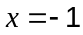. (1 mark)

Horizontal point of inflection

(d) Sketch the function on the axes below. (4 marks)
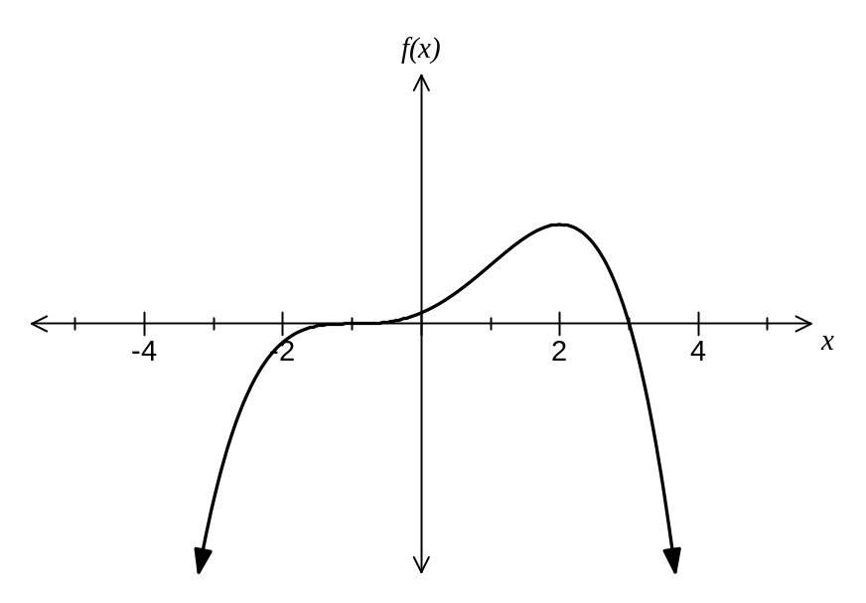

Question 17 (10 marks)
A rectangle OABC is such that O is always at the origin, A lies on the -axis, C lies on the -axis and B lies in the first quadrant on the curve 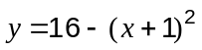.  1 unit on each axis is 1 cm. | 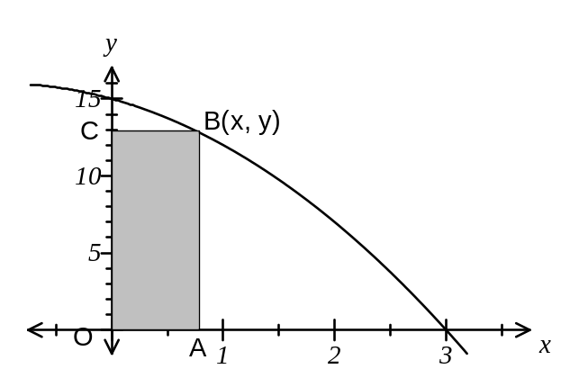

(a) Find the area of the rectangle when . (1 mark)
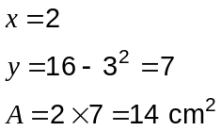

(b) Show that the area of rectangle OABC is given by 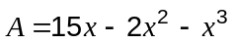, where is the -coordinate of corners A and B. (2 marks)

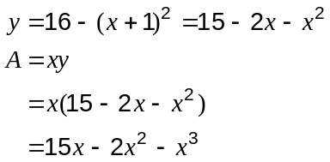

(c) Use calculus to determine the maximum area of the rectangle. (3 marks)

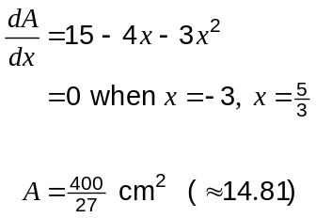

(d)
(i) Use the formula 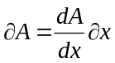 to find the approximate change in area of the rectangle when increases from 2 to 2.1 cm. (3 marks)

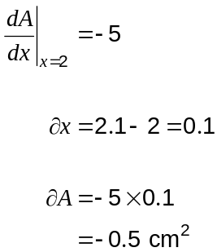

(ii) Interpret your answer to (d) (i) in the context of this question. (1 mark)

The area decreases by 0.5 cm² as increases from 2 to 2.1 cm.

Question 18 (8 marks)
A retailer has discounted the prices on 32 different music CD's, with 11 of them priced at $8 each and the rest on sale at $12 each.

(a) If a customer randomly selects two of the discounted CD's, what is the probability that they spend $24? (1 mark)
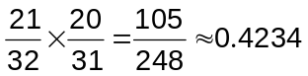

(b) If a customer decides to spend $24, how many different choices of CD's do they have?
(2 marks)
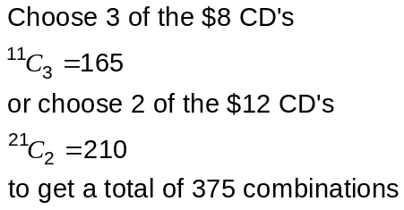

(c) If a customer decides to pick at least one CD and to spend no more than $24, how many different combinations of CD's could they buy? (4 marks)

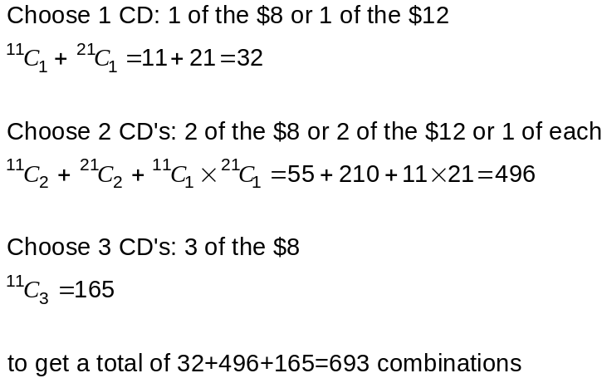

(d) Given that a customer randomly chooses one or more CD's and spends no more than $24, what is the probability that they spend exactly $24? (1 mark)
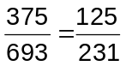

Question 19 (5 marks)
The daily increase,, in millions of organisms, of a colony in which each organism reproduces times per day can be modelled by 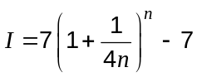.

(a) Determine the daily increase of the colony when the organisms reproduce

(i) twice per day. (2 marks)
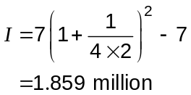

(ii) every half-hour. (1 mark)
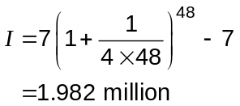

(b) If the organisms were to reproduce more frequently, could the daily increase of the colony exceed two million per day? Justify your answer. (2 marks)

No, as maximum occurs if organisms reproduce 'continuously', so that

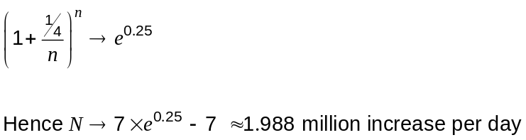

Question 20 (8 marks)
The manufacturer of an industrial item is concerned about the number of defectives being returned to the factory. The items are shipped in boxes of 24.

(a) 15 percent of a large production run is known to be faulty. If eight items are randomly selected from the production run, what is the probability that more than half of these items are faulty? (3 marks)

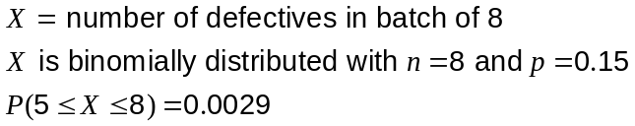

(b) The manufacturer trials a sampling plan to minimise the number of products returned. Five items are removed at random from each box of 24 and the box is not shipped if more than two defective items are observed in the sample.

If a box contains four defectives, what is the probability that

(i) The box is shipped? (3 marks)
Box not shipped if 3 or 4 defectives chosen.

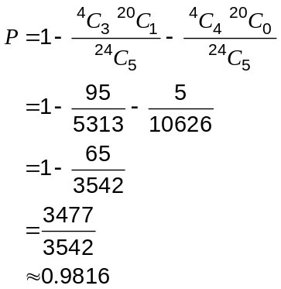

(ii) Two defective items are in the sample, given that the box is shipped? (2 marks)
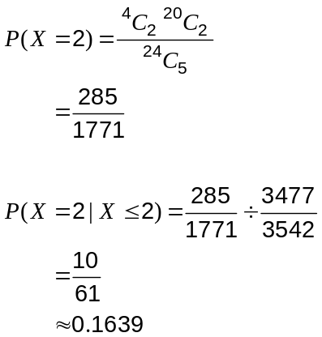

Additional working space

Question number: _________

Additional working space

Question number: _________

Additional working space

Question number: _________

This examination paper may be freely copied, or communicated on an intranet, for non-commercial purposes within educational institutes that have purchased the paper from WA Examination Papers provided that WA Examination Papers is acknowledged as the copyright owner. Teachers within purchasing schools may change the paper provided that WA Examination Paper's moral rights are not infringed.

Copying or communication for any other purposes can only be done within the terms of the Copyright Act or with prior written permission of WA Examination papers.

Published by WA Examination Papers
PO Box 445 Claremont WA 6910

